Making Music From Around the World

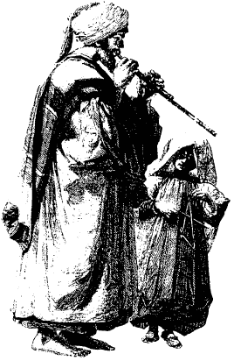

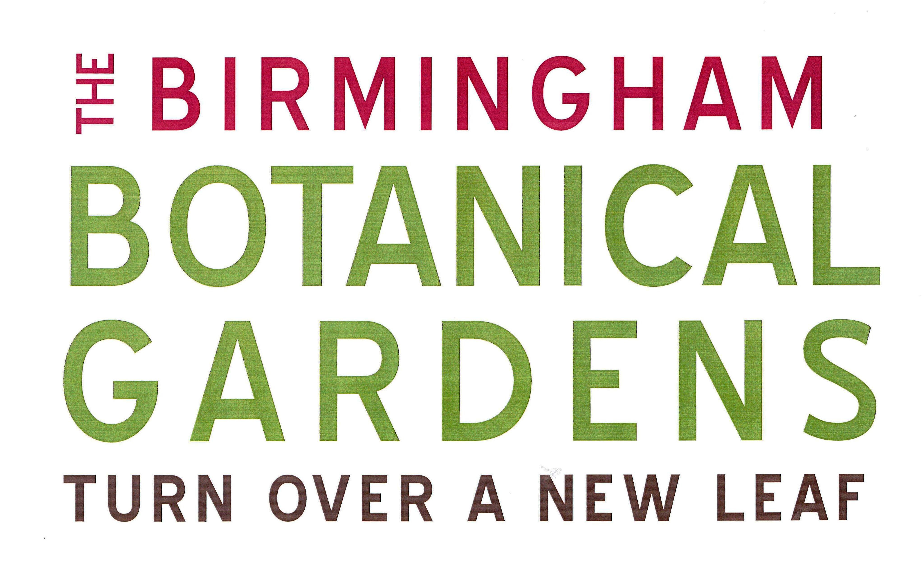

Introduction

At the Botanical Gardens we have an exciting collection of musical instruments made from natural materials, which come from around the world. These instruments are available for the Musical Rainstorm teaching session (EYFS/KS1/KS2), which allow pupils to explore a new world of sound and learn more about the places they come from and the people who make them.

This booklet describes the fascinating instruments available, the plant materials used in their construction and the practical, fun activities that can be carried out with the pupils at the Gardens in your self-guided time.

Acknowledgements

Many thanks go to Andy Wilson from Knock on Wood for supplying us with most of our instruments and helpful background information.

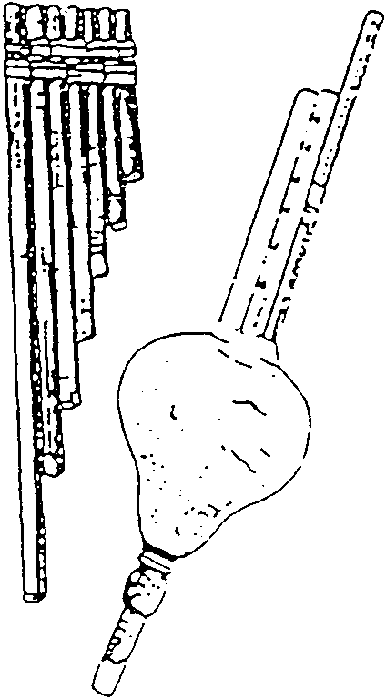

Musical Instruments from Africa

Bean Pod Rattle

Perhaps the simplest rattle of them all. Our example is the pod of the Royal Poinciana tree from Madagascar.

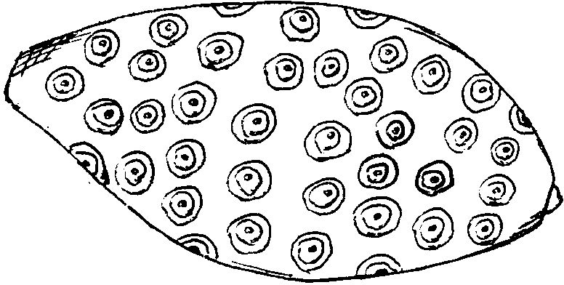
Baobab Rattle

Another simple rattle using the fruit and seeds of the Baobab tree.

Capala
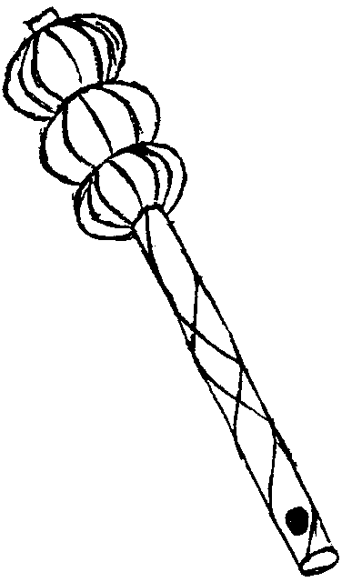

Another kind of seed pod rattle. Possibly using fruits from the Passiflora group of plants, threaded onto a stick.

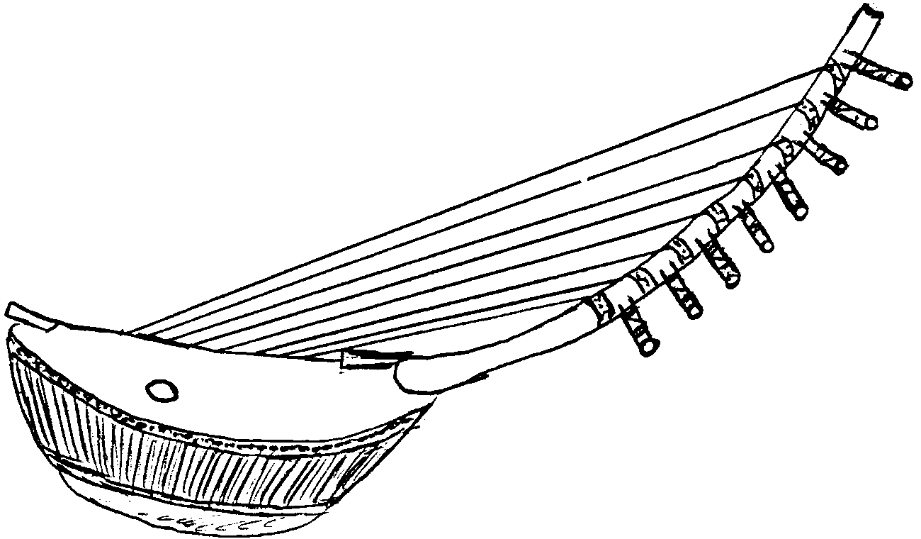
Nyatti

Uses a calabash (a type of gourd)
as the body of the instrument
which acts as the sound box.

Caxixi (pronounced ka-shee-shee)
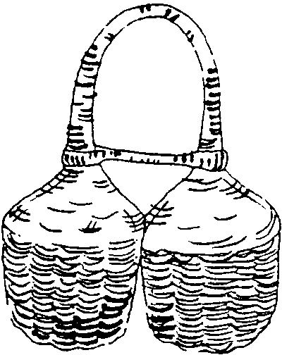

A strong, split cane woven basket rattle from Cameroon. It gives a softer sound than a gourd body.

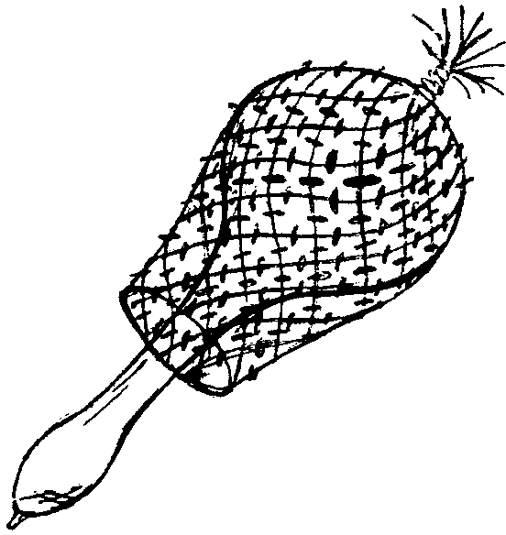
Chekere (pronounced shek-err-ee)

A shaker made from a dried bottle gourd with hard seeds threaded on a net around the outside. This version is from Ghana.

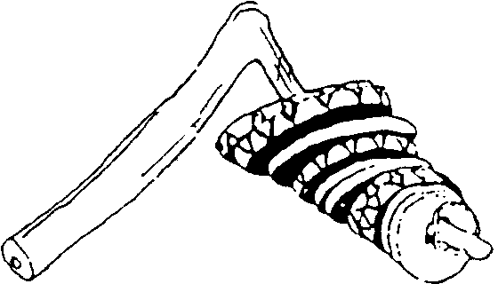
Rakatak

A rattle from Senegal made from small discs of dried
Gourd on a natural piece of branch.

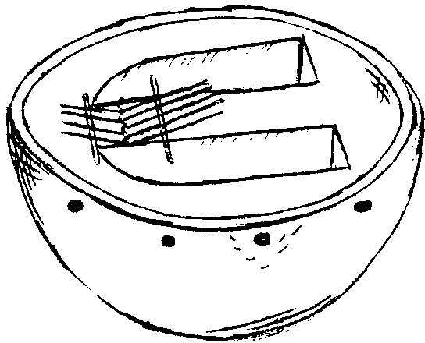
Kalimba

Sometimes called the “thumb piano”, this instrument
makes its mellow sound by means of thin tongues of
steel of varying lengths attached to a sound box. This
version is from Tanzania.

Musical Instruments from Latin America

Panpipes
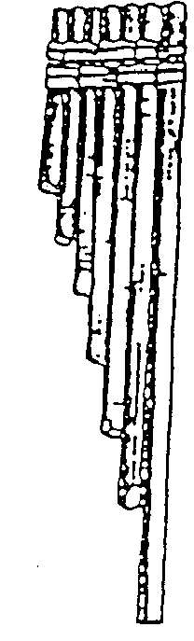
Andean panpipes from Peru made of bamboo and held together by a strip of reed. Air is blown across the sharp edge of the open end of the pipes. The length of pipe determines pitch.

Quena

The flute of the Andes. Played by blowing across an edge cut in the end rather than the side of a bamboo cane tube.
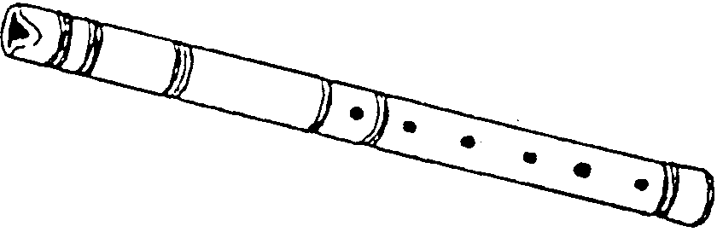

Berimbau

This simple instrument is thought to have developed from the hunting bow. The single string on this musical bow can be plucked or struck with a stick to make a sound. A gourd resonator is attached to the string and its open end can be pressed against the chest to give added resonance.
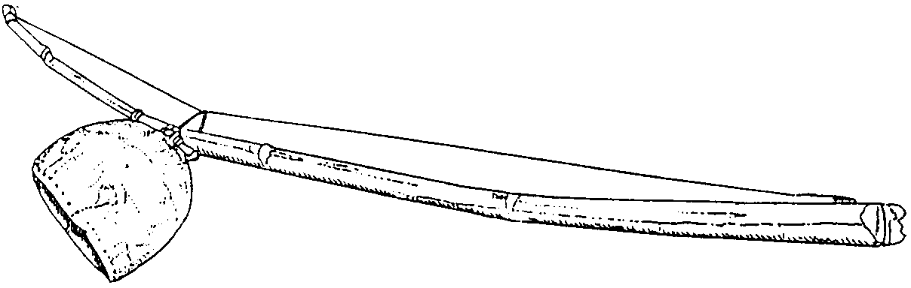

Maraccas
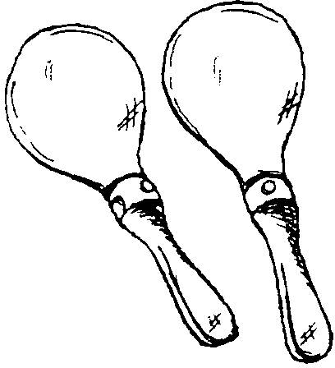

Made from gourds with wooden handles.

Rainmaker

An inside-out cactus stalk from Chile, which contains seeds. When upended, the seeds cascade down the internal baffles to evoke the sound of falling rain.
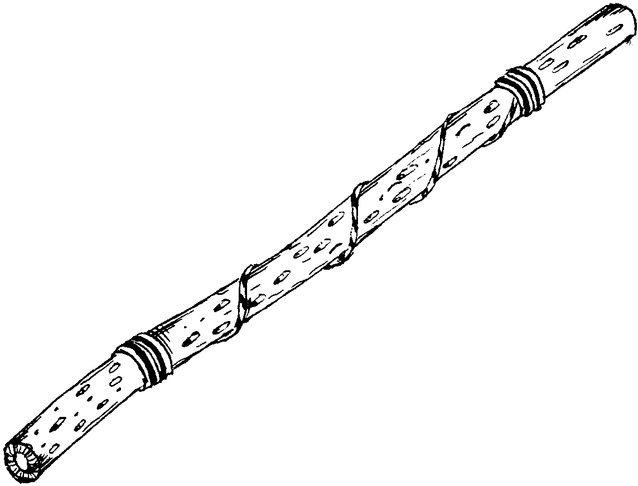

Musical Instruments from Australia

Concussion Sticks

One of the most basic ways of producing a rhythmic sound is by striking together two similar objects. The size, shape and type of wood (hardwood and softwood) influences the sound made.
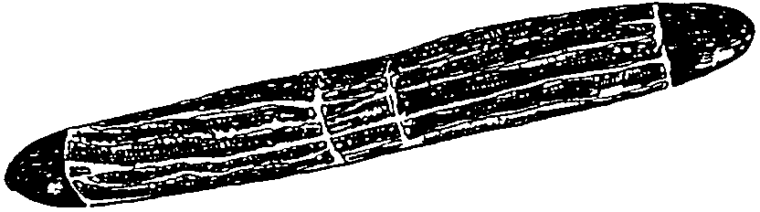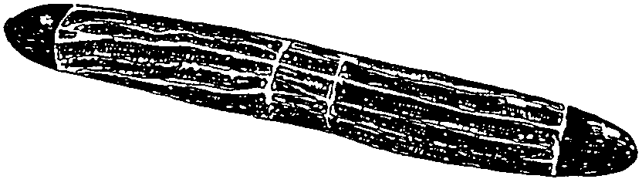

Didgeridoo

Made from a long straight branch of eucalyptus, which is buried in the ground so that termites bore out the middle. They are usually decorated with ritual motifs and coloured with earth pigments.
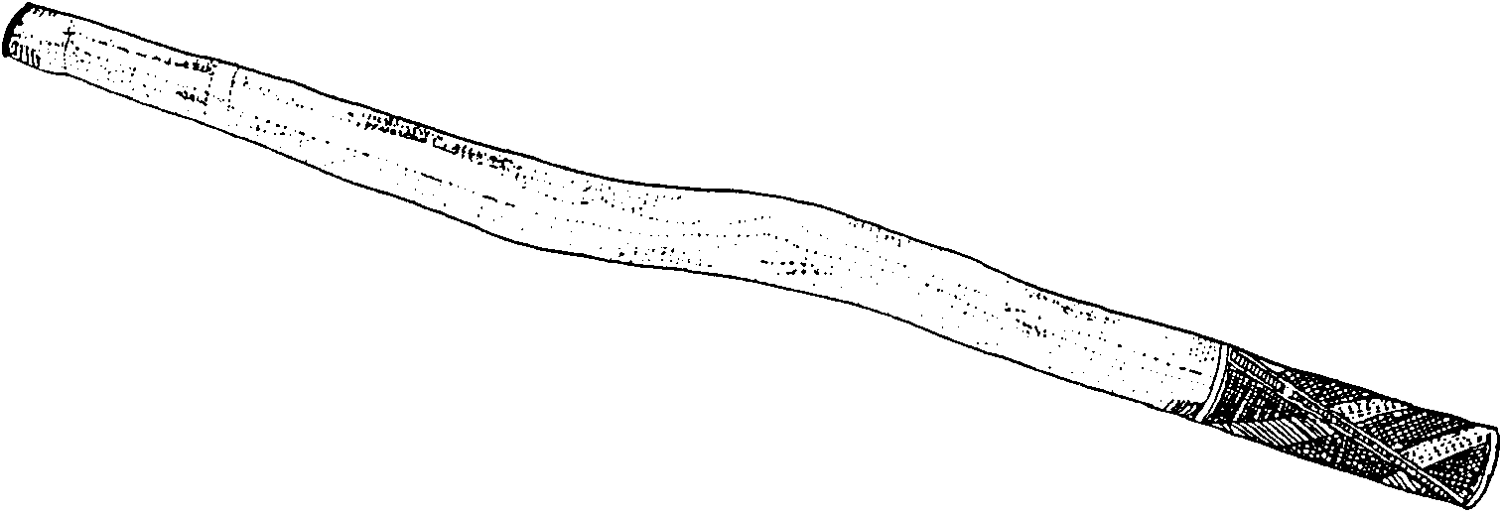

Musical Instruments from Asia

South-East Asia

Anklung
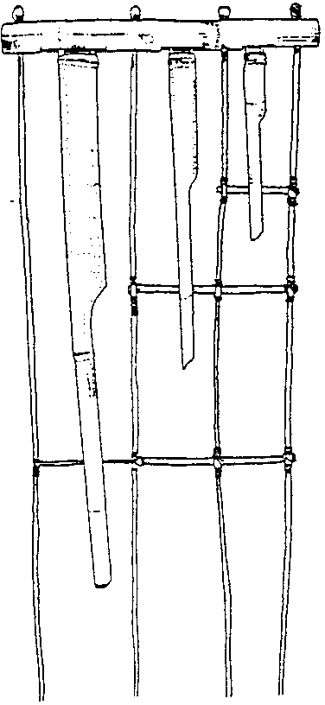
This instrument from Java is made of three bamboo tubes set into a groove in the base of a bamboo and rattan frame. When shaken, the tubes slide backwards and forwards in the groove, striking the rim and making a note. Anklungs are usually made in sets, each tuned to a different note.

India

Indian Flutes

Made from bamboo and ranging in length from 15-60cm, they give a warm, mellow tone.

Snake Charmer’s Pipe

The pipes and mouth piece are made from wood and a coconut is used as a wind reservoir. This reed instrument is an example of a double clarinet where one pipe is a drone and the other pipe is for the melody.
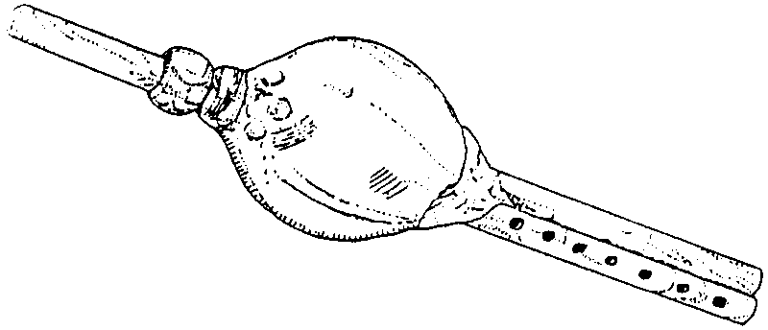

Plants Used For Instruments

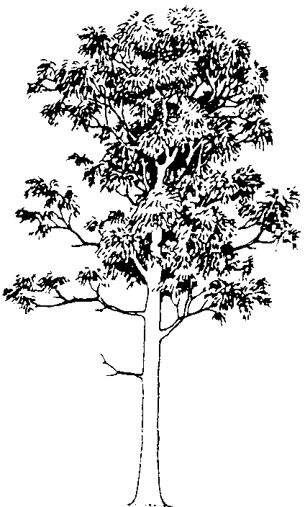
Eucalyptus

Aromatic and evergreen trees often with interesting bark colour and
texture. In Australia, long straight branches of the tree are used to
make the didgeridoo.

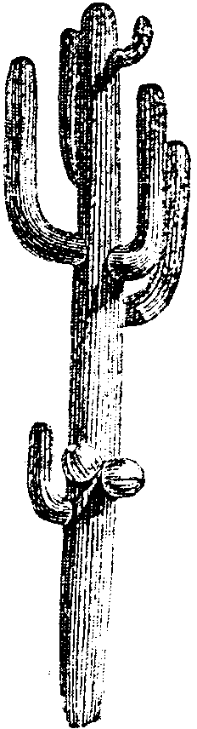
Cereus

These cacti from S. America have upright stems, which are ribbed and
covered in spines. Traditionally used to make rainmakers.

Royal Poinciana
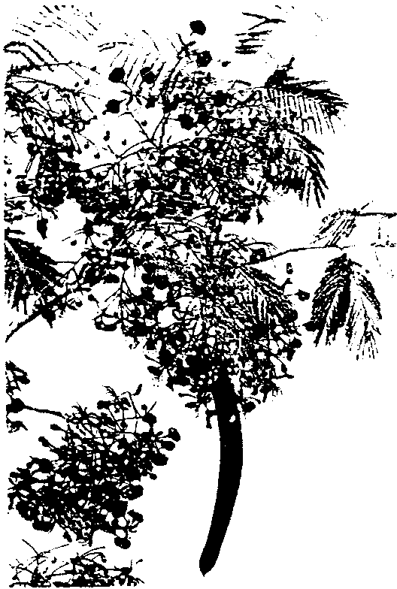
This small tree (Delonix regia) is planted worldwide in tropics for
its shade and exuberant blooms of scarlet flowers. It has large, flat
seed pods which are used as a rattle when dry.

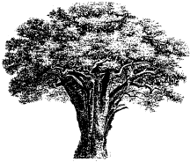

Baobab

Adansonia digitata is well known in Africa for its low spreading
canopy and enormous trunk. The tree can live for up to 2000
years. Its large woody, oblong fruits are used to make rattles.

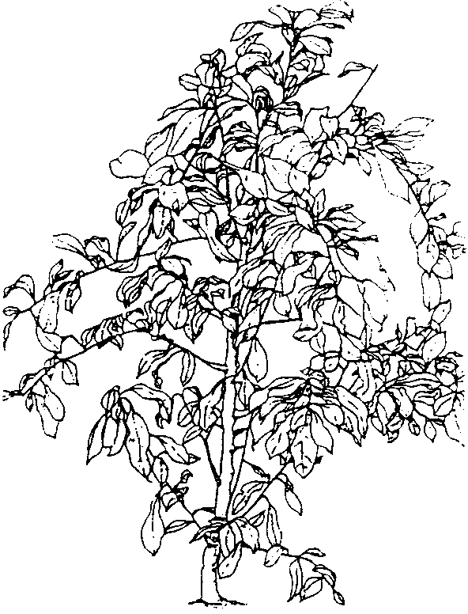
Rattan Canes

Rattans such as Calamus caesius are a group of thorny climbing
palms found in the canopy of tropical forests in South and South-
East Asia. The rope-like stems reach 100 metres in length.
Rattans are used to make the frames of instruments while thin
strips of “cane” are used for binding and decoration.

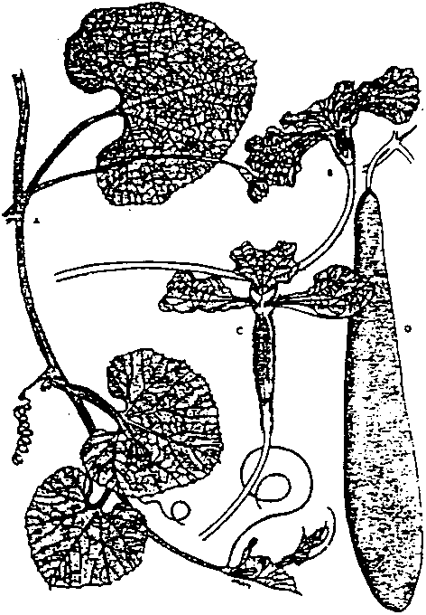
Calabash Tree

A native of tropical America, the calabash tree (Crescentia cujete)
gives thin woody gourd-like fruit. These tree gourds can be polished,
carved and used as musical instruments such as maracas.

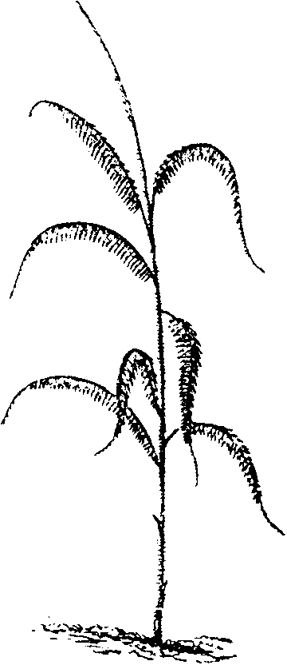
Bottle Gourd

Also known as calabashes, the bottle gourd (Lagenaria siceraria)
is not from the calabash tree. Instead it is a vine from the cucumber
family and climbs with the use of tendrils. The fruits come in an
amazing variety of sizes and shapes and are used across the world
to make instruments.

Bamboo
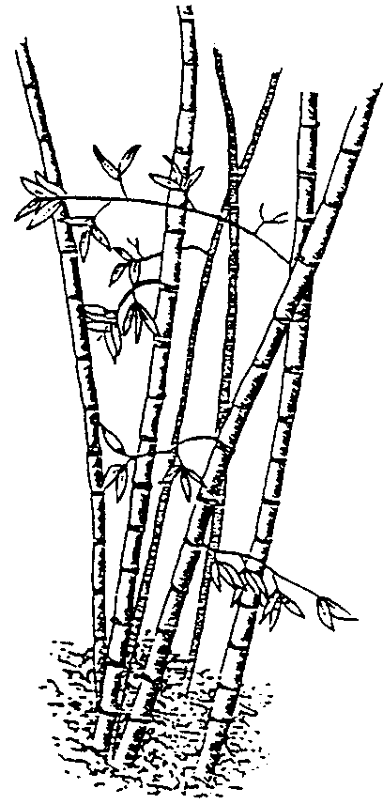
Many types of bamboo can be found growing around the world.
It is easily used to make into pipes but can also been found as
percussion and string instruments.

Possible Activities

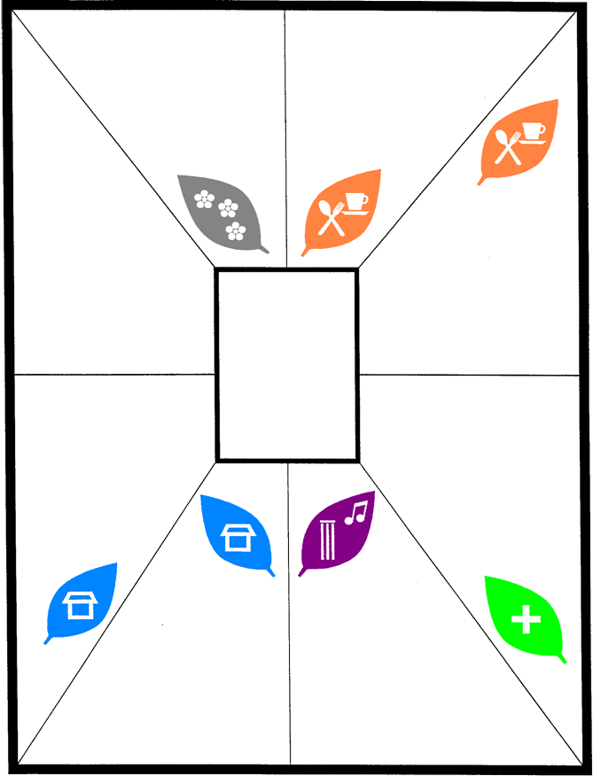
Many of the instruments are made from plant materials, which can be seen growing at the Botanical Gardens. Pupils can look for any of the plants that may be growing in the glasshouses (e.g. bamboo) and locate any other plants that can be used to make musical instruments – indicated by the following symbol on the plant label:

They could then draw the “musical” plants and experience the climatic conditions in which they grow.

Where in the World?

Maps of the world can be used to plot where the musical instruments originate. Information about countries of origin can be found elsewhere in this booklet.

Making Music

The many and varied environments at the Botanical Gardens are ideal stimuli for pupils to start making their own music. Two examples of the way in which our tropical rainforest has been used are given below:

Rain Dance

Arrange the group into a circle. The leader starts off by using their hands to create a sound. The pupil on the right copies this sound with each member of the circle taking up the same action as it passes around.

When the last pupil in the circle is reached, the leader changes the sound by making a new action with their hands. The pupils continue to make the first action until the child on their right starts the new action, which they then copy.

The actions can include:

- rubbing hands together
- tapping chest
- slapping knees
- shuffling feet
- slapping knees
- tapping chest
- rubbing hands together
- silence

Creating Rainforest Music

The group of pupils listen for one minute, noting everything they hear and words to describe the rainforest atmosphere. The use of stories and poems are a good way of creating mood. Pupils can then talk about:

- What sounds were heard and in what order?
- How can we represent the sounds on paper (signs, symbols, words)?
- Can we organise the sounds into a performance?
- Can we create a short piece of music using a selection of instruments that is in harmony with the rainforest environment?

Appendix – Instrument Families recording sheet

Name of instrument | Plant material (gourd, bamboo, eucalyptus, etc.) | Part of plant  (stem, trunk, fruit, seed, etc.) | How to make the sound (shake, blow, hit, pluck, etc.)

