Cool Plants!
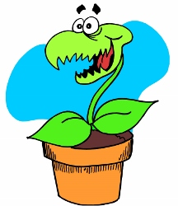

Carnivorous Plants

`Carnivorous` means to need meat for survival. That means carnivorous plants eat bugs and even small animals, like rats and frogs, to get the nutrients they need. (Like all plants, they still need water, light and air too.) There are over 600 types of carnivorous plants. They are usually quite small (up to 30cm) but some can grow up to 100cm tall. Most grow in soil but some can live in water.
Most people will know of the Venus Flytrap, but other popular carnivorous plants are: Sundews and Pitcher Plants, all of which grow in our Sub-tropical Glasshouse. Come and see them for yourself, if you dare!

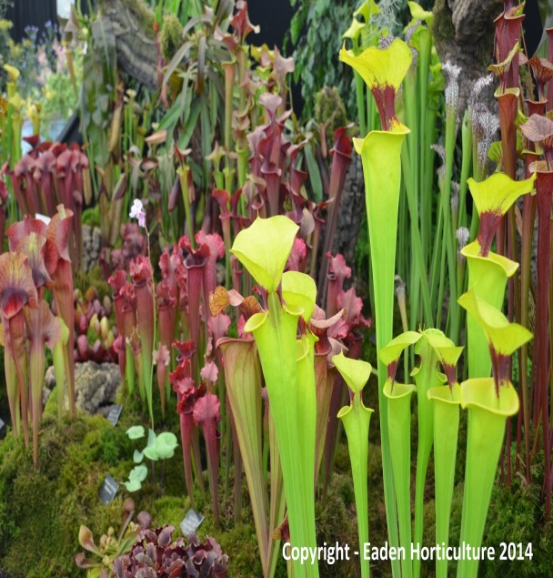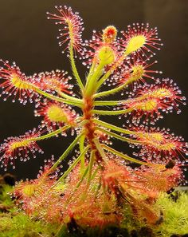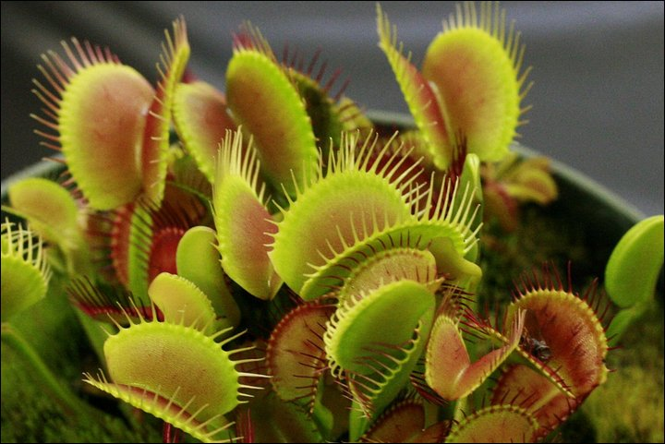
Venus Flytraps
(Dionaea muscipula)
Sundew
(Drosera)
Pitcher Plants
(Sarracenia)

Carnivorous plants catch their prey in different ways:

Snap traps: catch food by trapping it inside their leaves so it cannot escape. When food lands on the leaves of these plants, hairy-spikes snap shut almost instantly, trapping the food so it can be digested. (Venus Flytrap)

Pitfall plants: have slippery leaves that are funnel-shaped and point down towards the bottom of the plant. When food lands on the leaf, it slides down into a pool of digestive enzymes at the bottom. (Pitcher Plant)

Flypaper traps: `glue` themselves to their food. When food lands on a carnivorous plant like this, the sticky liquid on the plant keeps it from being able to get away and then digests it. (Sundew)
Bladder traps: live in the water. They suck food out of the water (like a vacuum cleaner) and into the `bladder` so that it can be digested.
Lobster traps: use tiny hairs which are all going in the same direction to force food to walk towards the pool of digestive enzymes at the bottom of the plant’s leaves.

So, why does prey not just keep away? Carnivorous plants are cleverer than that. They usually smell very sweet, are brightly coloured and make lots of sugary nectar to attract food to them, and then … yum yum!

Check out the next Cool Plants! to learn more or come and see them for yourself! Call 0121 450 5093 for more information or to book a visit.

