Cool Plants!
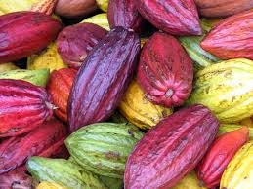

`Chocolate`

All chocolate comes from the cacao tree. It can take five years for cacao trees to produce pods with beans for making chocolate. Although cacao trees can live for two-hundred years, they will only grow beans for twenty-five years.
When the pods are ripe, the beans are taken out and roasted. This dries the beans so they can be crushed into cocoa powder. Plain cocoa is very bitter. It is not really chocolate until sugar is added.
A cacao tree produces about one thousand beans every year. People eat and drink so much chocolate that one billion cacao trees are needed every year to grow enough beans!
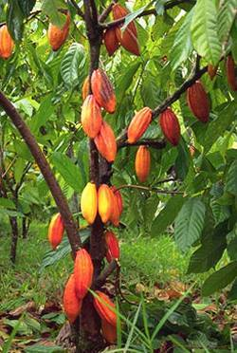
Fun Facts
- In 2016, the global chocolate market was worth £78.6 billion!
- Cote d’Ivoire, Ghana, Nigeria and Cameroon (in Western Africa) produce 3 million tonnes of the world’s annual 4 million cacao total!
- The Mayan people used cacao beans as money!
Cacao Tree
(Theobroma cacao)
Cacao Pod and Unprocessed Beans
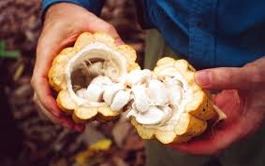
Come and see our cacao tree for yourself (Tropical Glasshouse), and see how much `chocolate` we grow!
Check out the next Cool Plants! to learn more or come and see them for yourself! Call 0121 450 5093 for more information or to book a visit.

