Cool Plants!
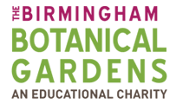

`Bamboo`

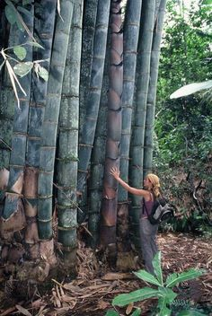
Bamboo is amazing! You can eat it, wear it, ride it, build with it, use it as medicine and tackle global warming with it. If you are intrigued then read on!
Bamboo can grow as tall as trees, but is actually a type of grass. There are almost 1,500 different types of bamboo that grow all around the world, but most can be found in warm, humid areas, like; South-East Asia, Central Africa and the Americas.
Bamboo is the fastest growing plant in the world – it can grow up to a metre in one day. The largest type of bamboo (Giant or Dragon Bamboo) can grow up to 40 metres tall (a 10-storey building).
Giant/Dragon Bamboo
Bamboo can live for up to 120 years and may take that long to flower just once. It does not need fertiliser, as the fallen leaves provide all the nutrients needed. Bamboo releases 30% more oxygen into the atmosphere and absorbs more carbon dioxide than other plants, helping it to decrease global warming.
Bamboo is often used in Asian-based cuisine, but young shoots contain poison that has to be destroyed by cooking at high temperatures before it can be eaten. It can also be used as a herbal medicine to treat infections and speed-up wound healing. Pandas are famous for eating only bamboo (up to 38 kg (24 house bricks) of leaves and shoots a day). Other animals, like Madagascan gorillas and lemurs, eat it as part of their diet.
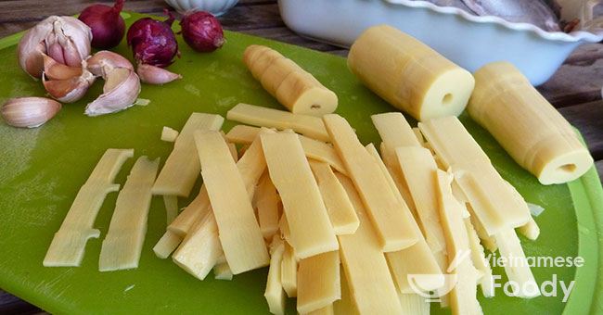
Bamboo Shoots
Bamboo is stronger than steel and can be used for building house walls and floors, as well as other things, like; furniture, and bicycle frames and helmets. It can also be used to make cloth, which is softer and better for sensitive skin than traditional clothes, as well as being more breathable (so you feel less sweaty) and naturally antibacterial (so your clothes smell less). It also blocks 97.5% of the Sun’s harmful UV rays to better protect your skin.
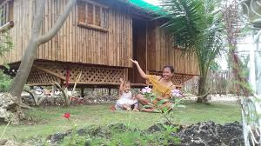
Bamboo House – over 1 billion people worldwide live in bamboo housing
Bamboo Bicycle (frame)
Come and see our many different types of bamboo for yourself, including our exciting bamboo maze!
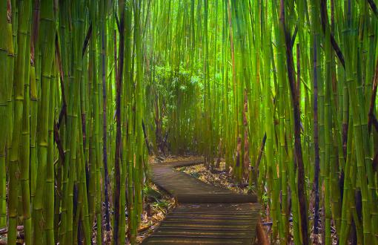
Bamboo Maze

Check out the next Cool Plants! to learn more or come and see them for yourself! Call 0121 450 5093 for more information or to book a visit.

