Cool Plants!

`Drinkable` Plants

What is your favourite drink? Cola? Tea? Juice? Chances are that one of its main ingredients grows right here at Birmingham Botanical Gardens.
Hot Drinks
Tea (Camellia sinensis) – is native to East Asia (China and Myanmar) but is now grown all over the world. New, small leaves are harvested every 7 – 14 days from which the tea can be made. A tea plant can live for 50 years and can be found in our Subtropical Glasshouse.
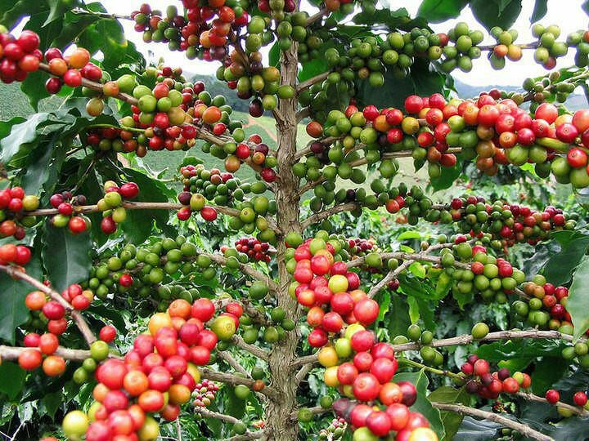
Coffee (Coffea arabica) – originated in the Ethiopian mountains in Africa. The tree grows edible red `cherries`, which each contain 2 seeds or `coffee beans` and can be seen in our Tropical Glasshouse.
Juices
A Coffee tree with ripe and unripe `cherries`
Juice is the natural liquid of fruit (and vegetables). We grow the fruits to make the UK’s 4 most popular single-flavour juices:
Orange – we grow lots of different varieties of orange; mandarins, satsumas, Seville oranges and tangerines. All of these can be spotted in our Mediterranean Glasshouse.
Apple – there are different species to be seen in our Growing Schools Garden.
Grapefruit (Citrus paradisi) – was first `made` about 250 years ago by crossing a sweet orange with a pumelo. It is unusual in that the fruits can be left on the tree to be harvested all year round and can be found in our Mediterranean Glasshouse.
Pineapple (Ananas comosus) – was first domesticated by Native Americans before the 15th century. It contains an enzyme, bromelain, which tenderises meat and its leaves can be used to make Pina cloth. Look hard (and low) for them in our Subtropical Glasshouse.
Fizzy Drinks
Kola Nut (Cola acuminata/nitida) – is the fruit of the Kola Tree. The trees have yellow flowers with purple stripes, and star-shaped fruit. The fruits contain the nuts which used to flavour drinks such as Coca Cola and Pepsi Cola, though this is now uncommon. Our Kola Nut tree can be found in the Tropical House. 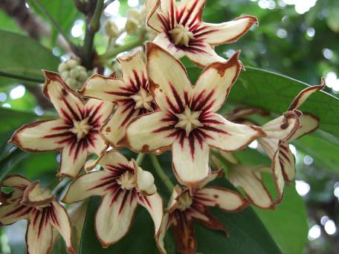 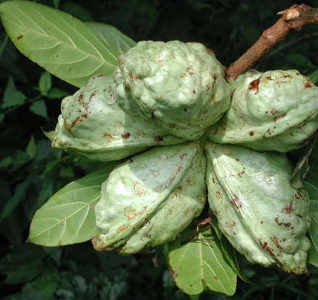
Kola fruit
Kola flowers
Sugar 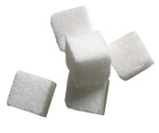
Though not a drink, sugar can be found in most drinks, either added by the drinker to sweeten tea or coffee, added in the factory while it is being made (e.g. cola) or found naturally in the fruits used to make juice.
Sugarcane (Saccharum officinarum) can be found growing in our Subtropical Glasshouse. After the sweetness has been removed, the crushed cane (bagasse) can be used to make paper, plastic, cattle food and ethanol (for biofuel and another, adult-only, drink - alcohol).

Come and see how many `drinks` you can find on a Glasshouse Tour or during a Rainforest Challenge teaching session!
Check out the next Cool Plants! to learn more or come and see them for yourself! Call 0121 450 5093 for more information or to book a visit.

