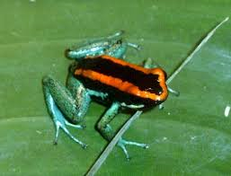

Kambo – one of our poison dart frogs!
Featured teaching session …

Rainforest
Fun
Discover our rainforest seeds, tribal artefacts and preserved creepy crawlies to better understand this fascinating environment. Learn about where rainforests are situated, the animals that inhabit them and why they are so endangered. Also, find out which rainforest plants we eat and which we wear, as well as a whole host of others that are part of our everyday lives, in this fun and highly interactive, fact-based session!
And, why not make your experience truly unforgettable by adding live animal handling to your session, at no extra cost!
To find out more or book this exciting experience for your students, please call 0121 450 5093.
