A Birmingham Botanical Gardens Acrostic Poem
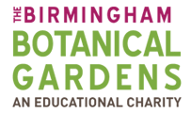

G_________________________
L_________________________
A_________________________
S_________________________
S_________________________
H_________________________
O_________________________
U_________________________
S_________________________
E_________________________

