What I Enjoyed at Birmingham Botanical Gardens
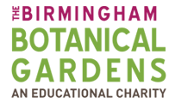

My favourite thing about Birmingham Botanical Gardens was _____________________________
_______________________________________
_______________________________________
_______________________________________.
I loved the ________________ plant. It ______
_______________________________________.

