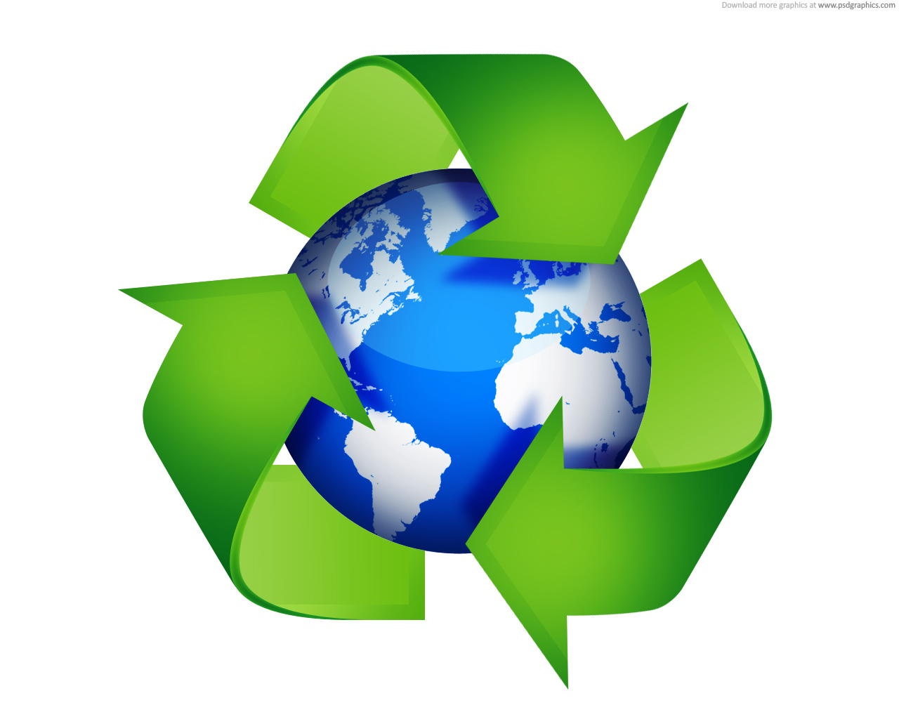
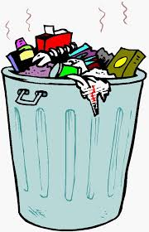

No Waste! – Schools Challenge
We would like to set a challenge to all school groups having lunch during their visit: to leave no waste behind.
The challenge is for pupils (and teachers) to bring a No Waste packed lunch and for anything left to be reused or recycled at home or school. This helps us to keep the Gardens looking beautiful and reduces our waste output too!
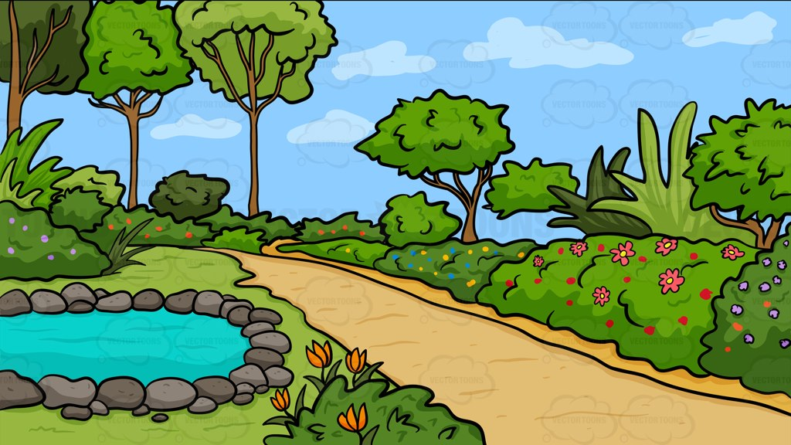

How can it be done?
- Reuse Packaging

- Bring your lunch in a lunch box that can be washed and reused. It stays fresher this way too.
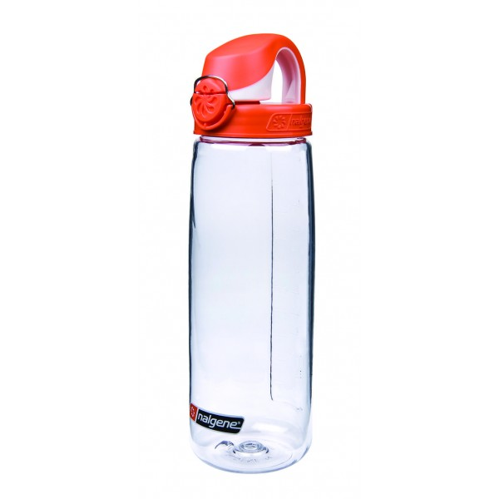
- Bring your drink in a reusable flask or plastic bottle.
- If you bring a plastic carrier bag, don’t bin it – use it again.
- If you need to use a knife, fork or spoon, use ones that can be washed and used again.
- Instead of buying separate individual servings of snacks (e.g. raisins), buy one large bag and put just a serving into a smaller reusable container – it is much cheaper to do this, so you will save money too!

- Recycle – waste not, want not

- Instead of a plastic carrier bag, use a recycled paper bag and then put it in the compost, or use it again.
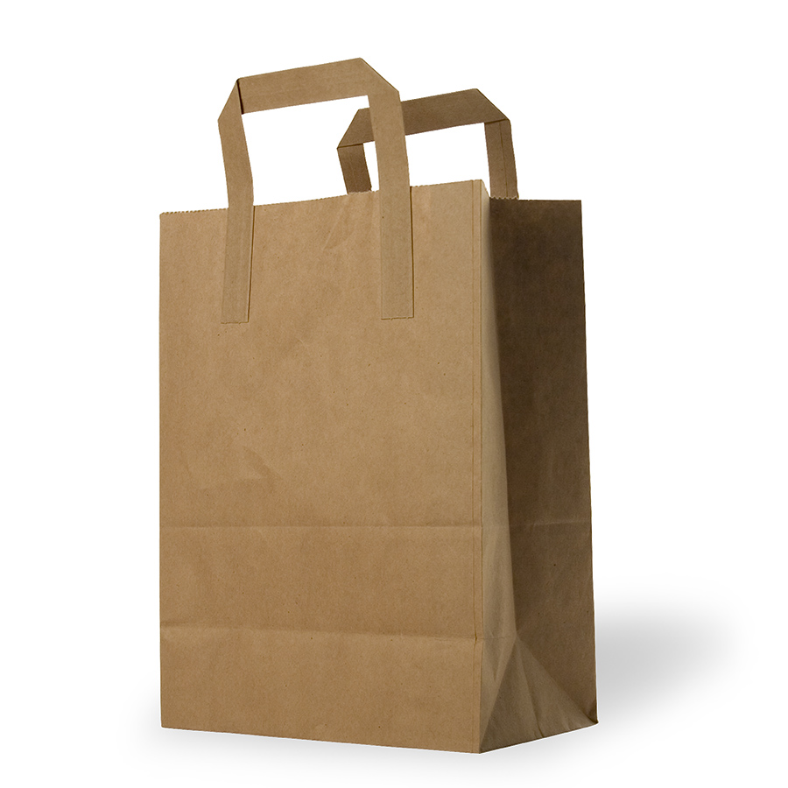
- Although drinks cans and glass bottles can be recycled, use a reusable drinks container instead, which can be used many times over.
- Wrap sandwiches in foil (not cling film) and recycle it with your home recycling.

- Quantity
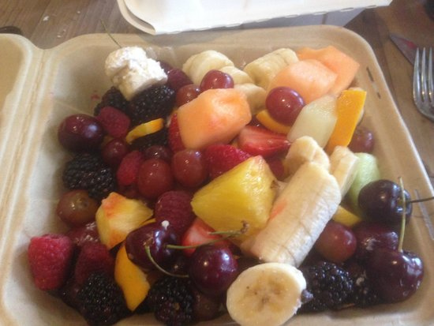
- Make sure you only bring as much food as you need so that you don’t waste any. If you do have any leftover fruit and vegetables, you can eat them later, compost them back at home or school, or `donate` it to our animals (via Education staff).

- Composting – your waste can be plant food
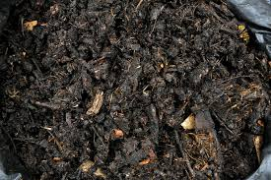
- Compost all of your fruit and vegetable waste.
- Shredded paper makes great compost too.
- The only things that you shouldn’t add to compost are cooked foods and meat.

- Try to avoid the bad stuff!
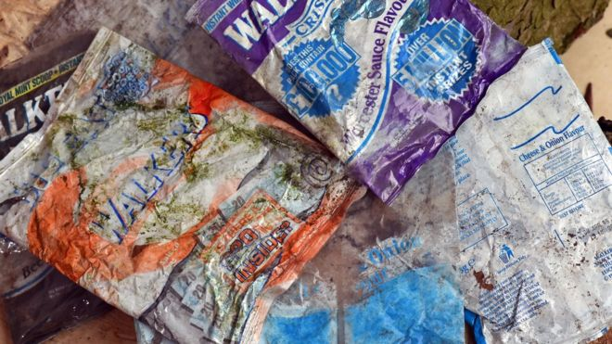
- Plastic – single-use containers and bags can’t always be recycled.
- Crisp packets are impossible to turn into compost!
- Pre-packaged foods.

How will you know if you have been successful?
On average, a class of 30 (and their teachers) will leave behind one full black sack of rubbish, which will have to be sent to landfill! If you can leave behind less waste than this, or hopefully none at all, then you will have passed our challenge and been successful in helping to reduce our negative impact on planet Earth.

Reduce, Reuse, Recycle – why bother?
Landfill sites are filling up with our rubbish more quickly than ever before.
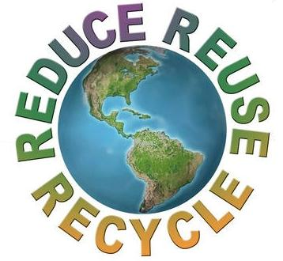
We need to try and reduce the waste created by buying less, reuse what
we buy as much as possible, and recycle when we can’t do the others!
Looking at your packed lunch is a good way to see just how much waste is
created by one person, for one meal, for one day. You can make a start by
ensuring that your lunch is as waste free as possible.

What else could you do?
Now you’ve got the hang of it, try having a Waste Free Lunch Day once a
week at school. The winners could get extra house points or other prizes!
Maybe you could do boys versus girls, just to see who is the most
wasteful – perhaps the winners could be champions for the week?
Some `Rubbish` Facts!
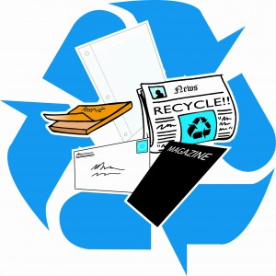

Facts about paper!
- The average person living in the UK uses around 200 kg of paper every year.
- Paper and cardboard make up 40% of the waste collected for recycling from UK households.
- For every tonne of recycled newspaper, 17 trees are saved.
- Recycling paper saves almost 80% of the energy needed to make paper from new raw materials.
- It takes just 7 days for old magazines and newspapers to be recycled into new ones
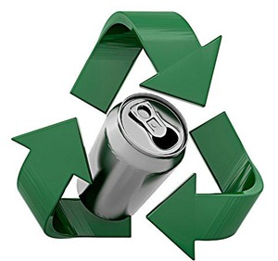

Facts about cans!
- Aluminium cans are lighter than steel, and the base of an aluminium can is shinier. A magnet will stick to a steel can, but not an aluminium one.
- Making one can from raw materials uses the same amount of energy as recycling 20.
- The average UK household uses around 600 steel cans every year.
- The aluminium drinks can is the world’s most recycled packaging container – over 50% are recycled.
- Recycling one aluminium can saves enough energy to power your television for 3 hours.
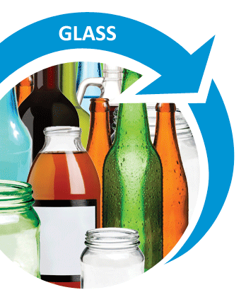

Facts about glass!
- Around 14 million glass jars and bottles are sent to landfill every year in the UK.
- Recycling one glass jar saves enough energy to power your computer for 20 minutes.
- Glass can be recycled again and again – containers made from recycled glass are of the same quality as those made from new raw materials.
- Green glass bottles are made with up to 90% recycled glass.
- The glass recycled in the UK each year saves enough energy to launch 9 space shuttles.
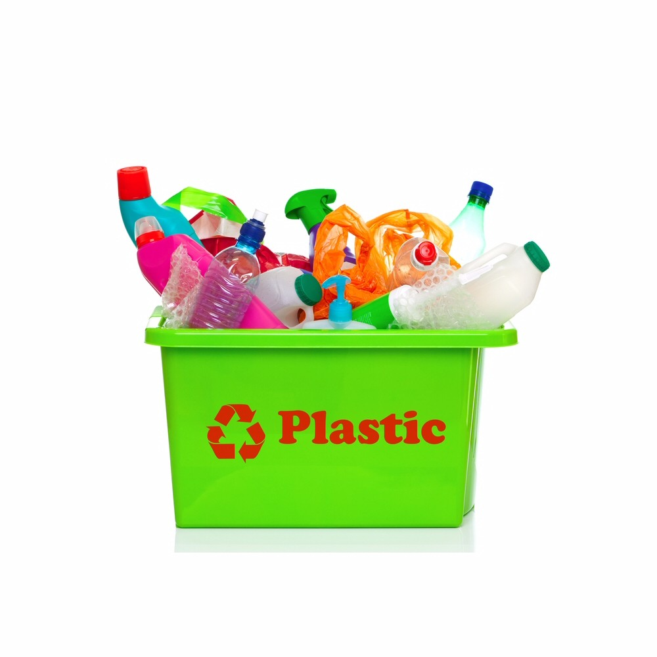

Facts about plastic!
- In the UK, we throw away about 455,000 tonnes of plastic bottles every year – about 9 billion bottles.
- It takes just 25 two-litre plastic bottles to make a recycled fleece jacket.
- Recycling just 1 plastic bottle saves enough energy to power a lightbulb for 6 hours.
- About 11% of our household waste is plastic and 40% of this is plastic bottles.

Facts about waste in the UK!
- Each UK home produces over 1 tonne of waste a year. This is the weight of a small car.
- In less than 2 hours, the UK produces enough waste to fill the Albert Hall.
- Every year, the average dustbin contains enough unused energy for heating 500 baths or 3,500 showers, or powering 5,000 hours of television.
- On average, every person in the UK throws away their own body weight in waste every 7 weeks.
- Up to 60% of the waste that ends up in the bin could be recycled.

